**Git Tutorial**

1: To create new Repository in the Git window, type **Git init WebApp**

2: To list the content of a folder, Right click on a folder and type **ls or ls –al**  (meaning list all files)  
 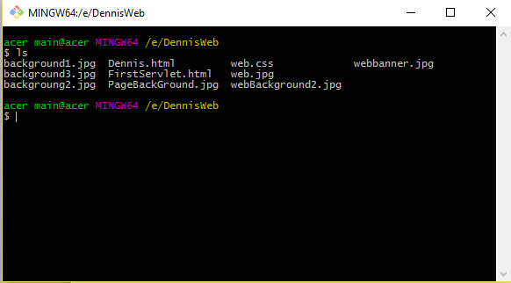

3: If you want to create a new Repository on GetHub for this project, while in the   
 project folder, type **git init** 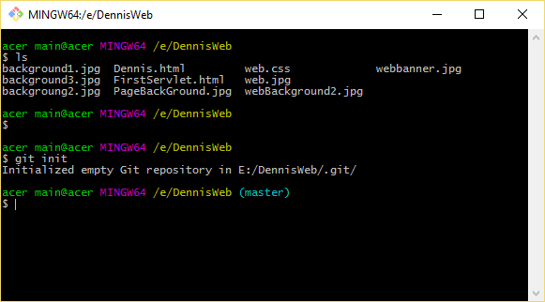

**4:** To transfer your local project files to your new GetHub Repository, go inside   
 the project folder where youcreated the Repository with the .git and create a   
 **Readme file** which is like an online description that you provide to anyone   
 who might be interested in learn about or using your project.

Now, in the folder, type: **echo “# myWeb_Project” >> README.md**   
> Here, we create a file called README and sending content into it using the echo  
 command.

Now to see the content of the README.md file do this: **cat README.md**  
 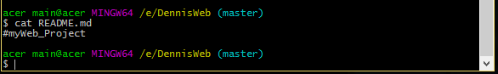

**5:** Create a **gitignore file that tells git what to ignore in our project file. It is good   
 if you have file in this directory you don’t want to upload to the online   
 Repository.** 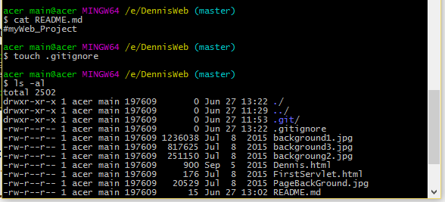

**6: Now you will upload file to your local Repository and Commit it to your   
 GetHub online Repository.**

**$ git add –all**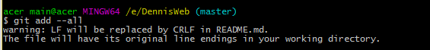

**7: To check to make sure that all the files were added to our local Repository we   
 type: $git status**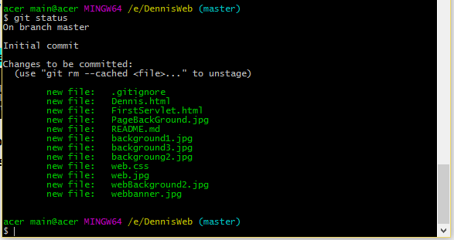

**8: Now we commit it to our local Repository  
 Commit-> means we made a change and we want to add the change to our   
 Repository. Commit creates a history inside the Repository of changes   
 has been made from this point forward. It enable us access an earlier version   
 of our project.**

* **Now to commit, type: git commit –m “Initial commit”**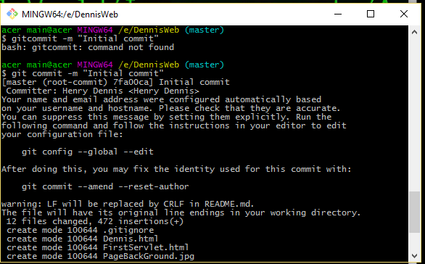

**9: To commit our local Repository files to our online Repository on   
 GetHub, type the following:  
 -> git remote add origin** [**https://github.com/hdennis84/Dennis-Web**](https://github.com/hdennis84/Dennis-Web)

**->Now push the files from the local Repository to our GetHub Repository,   
 type: git push –u origin master**

**10: After making an update to the project, go back into the console and   
 do this:**